Feature flag management
A

Project Report

Submitted in partial fulfillment of the requirement for the award of Degree of

Bachelor of Computer Applications

Submitted to

445 – Catalyst College, Patna



Submitted By | Under Joint Guidance of
Rana Pratap Singh  Registration No- 202344500160  BCA-3rd Year  Session-2023-2026 | Prof. Ravi Kumar Soni &  Prof. Murali Manohar  [Asst. Professor]  Computer Science & Applications


Catalyst College, Patna

Department of Computer Science & Applications

Session 2023-2026

DATE:…………………

CERTIFICATE


This is to certify that the work embodies in this project entitled, “Feature flag management”, being submitted by Rana Pratap Singh (202344500160) in partial fulfillment of the requirement for the award of “Bachelor of Computer Applications” to PATLIPUTRA UNIVERSITY, PATNA during the academic year 2023-26 is a record of bonafide piece of work, carried out by him/her under our/my supervision and guidance in the “Department of Computer Science & Applications”, Catalyst College, Patna.

Dr. Neeraj Agrawal | Dr. Neeraj Kumar | Dr. Amit Kumar Shukla
Director cum Principal | Dean- Academics | Head of Department


Catalyst College, Patna

Department of Computer Science & Applications

Session 2023-2026

Date:

APPROVAL CERTIFICATE

The project report entitled “Feature flag management”, being submitted by

Rana Pratap Singh (202344500160) has been examined by us and is hereby approved for the award of degree “Bachelor of Computer Applications”, for which it has been submitted. It is understood that by this approval the undersigned do not necessarily endorse or approve any statement made, the opinion expressed or conclusion drawn therein, but approve the project only for the purpose for which it has been submitted.

(Internal Examiner) (External Examiner)
Date: Date:


Catalyst College, Patna

Department of Computer Science & Applications

Session 2023-2026

Date:

DECLARATION

I, Rana Pratap Singh hereby declare that the work, which is being presented in the project report entitled “Feature flag management”, partial fulfillment of the requirements for the award of degree of “Bachelor of Computer Applications” submitted in the department of Computer Science & Applications (Catalyst College) is an authentic record of my own work carried under the joint guidance of Prof. Ravi Kumar Soni Sir and Prof. Murali Manohar Sir. I have not submitted the matter embodied in this report for the award of any other degree.
Rana Pratap Singh
Registration No 202344500160
BCA 3rd Year
Session-2023-2026
ACKNOWLEDGEMENT

“A journey is easier when you travel together. Interdependence is certainly more valuable than
independence.”

I would like to thanks, Prof. Ravi Kumar Soni Sir and Prof. Murali Manohar Sir, for providing regular guidance and insight into my project work. I also thank them for all advice he has given me in the past year, and for always having time for me, whenever I needed.

I give special thanks to Dr. Amit Kumar Shukla Sir, Prof. Raju Upadhyay Sir, and Prof. Niraj Kumar Singh Sir for always being willing to help find solutions to any problems I had with my work.

“The completion of any project depends upon the cooperation, coordination, and combined efforts of several resources of knowledge, inspiration, and energy”.

I also extend my deepest gratitude to Director, CIMAGE GROUP OF INSTITUITIONS, PATNA, Dr. Neeraj Agrawal Sir, Dean CIMAGE GROUP OF INSTITUITIONS, PATNA, Dr. Neeraj Kumar Sir and Centre Head Mrs. Megha Agrawal Ma’am for providing all the necessary facilities and true encouraging environment to bring out the best in my endeavors.

I express my gratitude and thanks to all the staff members of Computer Science departments for their sincere cooperation in furnishing relevant information to complete this Project well in time successfully.

I extend a special word to my friends, who have been a constant source of inspiration throughout my project work.

Lastly but not least I must express my cordial thank to my parent and family members who gave me the moral support without that it is impossible to complete my project work. With this note, I thank everyone for the support.

(Rana Pratap Singh)

Registration No : 202344500160

BCA 3rd Year
Session-2023-2026

CONTENTS

INTRODUCTION 8
OBJECTIVE 9
PROJECT CATEGORY JAVA 10
ADVANTAGES OF JAVA 11
TOOLS/PLATFORM required 13
HARDWARE & SOFTWARE REQUIREMENTS 13
PROBLEM DEFINITION 15
REQUIREMENT SPECIFICATIONS 14
PROJECT PLANNING & SCHEDULING 16
GANTT CHART 18
PERT CHART 20
SYSTEM ANALYSIS 21
FEASIBILITY STUDY 23
DFD 25
MODULE DESCRIPTION 26
DATA STRUCTURE Snap shot 17
LIST OF REPORTS 41
SCOPE AND FUTURE ENHANCEMENT 42
IMPLEMENTATION METHODOLOGY 42
TESTING 44
LIMITATIONS AND FURTHER ENHANCEMENTS 48
SECURITY MECHANISM 50
SNAPSHOTS 51

FEATURE FLAG MANAGEMENT SYSTEM

INTRODUCTION

The “Feature Flag System” is a modern software solution designed to control application features dynamically without modifying the code or redeploying the application. In traditional software development, whenever a new feature is introduced or an existing feature needs to be updated, developers must change the code and redeploy the entire system. This process is time-consuming and increases the risk of system failure if any issue occurs.
To overcome these challenges, the Feature Flag System provides a flexible approach to enable or disable features in real time. It allows developers and administrators to manage application behavior instantly, making the system more efficient and reliable.
This project is developed using Java with Spring Boot for backend processing. PostgreSQL is used as the database to store feature-related data permanently, while Redis is used as a caching layer to improve performance by storing frequently accessed data in memory. Docker is used to run all components in isolated containers, ensuring easy setup and consistency across different environments.
The system works by first checking the feature status in Redis. If the data is available, it is returned immediately, resulting in fast response time. If the data is not available in Redis, the system fetches it from the PostgreSQL database and stores it in Redis for future use. This caching mechanism reduces database load and enhances overall system performance.

Overall, the Feature Flag System provides real-time control, improved performance, reduced risk, and better flexibility in managing application features. It is widely used in modern software development for safe deployment, testing, and efficient feature management.

OBJECTIVE
To dynamically enable or disable application features in real time without redeployment, improving performance, flexibility, and reducing system risk.

The objectives of this system:

• To enable or disable features in real time
• To reduce risk during feature deployment
• To improve performance using Redis caching
• To reduce database load
• To provide flexible feature control
• To support scalable system design

PROJECT CATEGORY JAVA

The Java is a programming language originally developed by James Gosling at Sun Microsystems (which is now a subsidiary of Oracle Corporation) and released in 1995 as a core component of Sun Microsystems' Java platform. The language derives much of its syntax from C and C++ but has a simpler object model and fewer low-level facilities. Java applications are typically compiled to bytecode (class file) that can run on any Java Virtual Machine (JVM) regardless of computer architecture. Java is general-purpose, concurrent, class-based, and object-oriented, and is specifically designed to have as few implementation dependencies as possible. It is intended to let application developers "write once, run anywhere". Java is considered by many as one of the most influential programming languages of the 20th century, and widely used from application software to web application.[9][10]
The original and reference implementation Java compilers, virtual machines, and class libraries were developed by Sun from 1995. As of May 2007, in compliance with the specifications of the Java Community Process, Sun relicensed most of their Java technologies under the GNU General Public License. Others have also developed alternative implementations of these Sun technologies, such as the GNU Compiler for Java and GNU Classpath.

ADVANTAGES OF JAVA

- Java is simple: Java was designed to be easy to use and is therefore easy to write, compile, debug, and learn than other programming languages. The reason that why Java is much simpler than C++ is because Java uses automatic memory allocation and garbage collection where else C++ requires the programmer to allocate memory and to collect garbage.

- Java is object-oriented: Java is object-oriented because programming in Java is centered on creating objects, manipulating objects, and making objects work together. This allows you to create modular programs and reusable code.

- Java is platform-independent: One of the most significant advantages of Java is its ability to move easily from one computer system to another.

- Java is distributed: Distributed computing involves several computers on a network working together. Java is designed to make distributed computing easy with the networking capability that is inherently integrated into it

- Java is interpreted: An interpreter is needed in order to run Java programs. The programs are compiled into Java Virtual Machine code called bytecode.

- Java is secure: Java is one of the first programming languages to consider security as part of its design. The Java language, compiler, interpreter, and runtime environment were each developed with security in mind.

- Java is robust: Robust means reliable and no programming language can really assure reliability. Java puts a lot of emphasis on early checking for possible errors, as Java compilers are able to detect many problems that would first show up during execution time in other languages.

- Java is multithreaded: Multithreaded is the capability for a program to perform several tasks simultaneously within a program. In Java, multithreaded programming has been smoothly integrated into it, while in other languages, operating system-specific procedures have to be called in order to enable multithreading.

TOOLS/PLATFORM REQUIRED

Operating System

- Windows / Linux /macOs

HARDWARE & SOFTWARE REQUIREMENTS

Hardware Requirements:

• Processor: Intel i3 or above
• RAM: Minimum 4 GB (8 GB recommended)
• Storage: At least 10 GB free disk space
• System Type: 64-bit Computer/Laptop
• Network: Internet connection for setup and dependencies

Software Requirements:

• Programming Language: Java (JDK 8 or above)
• Framework: Spring Boot
• Database: PostgreSQL
• Caching System: Redis
• Container Platform: Docker
• Build Tool: Maven

• IDE: IntelliJ IDEA / VS Code
• API Testing Tool: Postman

PROBLEM DEFINITION

In traditional systems, features require code changes and redeployment, causing delays, high risk, and poor performance due to direct database dependency.

REQUIREMENT SPECIFICATIONS

The system requires Java with Spring Boot for backend development, PostgreSQL for storing feature flag data, and Redis for caching to improve performance. Docker is used for containerization and easy deployment. The system must provide REST APIs to create, update, and retrieve feature flags. It should allow real-time enabling or disabling of features without redeployment. The application must ensure fast response time, reduce database load using caching, and maintain data consistency. Additionally, it should be scalable, reliable, and easy to maintain for future enhancements like percentage-based feature rollout and advanced feature management.

The general requirements of the project are:

• The system should provide real-time feature control (ON/OFF)
• The system must be fast and responsive using caching
• The system should reduce database load
• The system must be scalable and reliable
• The system should be easy to maintain and extend

The development of the Feature Flag System was carefully planned and executed in a structured manner to ensure efficiency and proper functionality. In the initial phase, requirement analysis was performed to understand the need for dynamic feature control and to identify the key objectives of the system. This was followed by the system design phase, where the overall architecture, data flow, and database schema were defined.
In the development phase, the backend of the system was implemented using Java and Spring Boot. PostgreSQL was used for storing feature flag data, and Redis was integrated as a caching layer to improve performance. REST APIs were developed to handle feature creation, updates, and retrieval.
After development, the system was tested using tools like Postman to verify API functionality and ensure that feature flags were working correctly. In the deployment phase, Docker was used to run the application in containers, making the setup simple and consistent.
Finally, maintenance and future planning were considered to improve system performance, fix any issues, and add enhancements such as percentage-based feature rollout and advanced feature management capabilities.

GANTT CHART
The Gantt chart represents the project planning and scheduling of the Feature Flag System over a period of three months, from January to March. It shows the timeline of different phases involved in the project development.
In January, the project begins with requirement analysis and system design, where the basic structure and planning are completed. In February, the main development phase takes place, where the backend system is implemented using Spring Boot, along with database and Redis integration.
In March, testing and deployment are carried out to ensure the system works correctly. Finally, the maintenance phase continues to improve performance and fix any issues.
This chart clearly illustrates the step-by-step progress of the project and helps in effective time management and task org
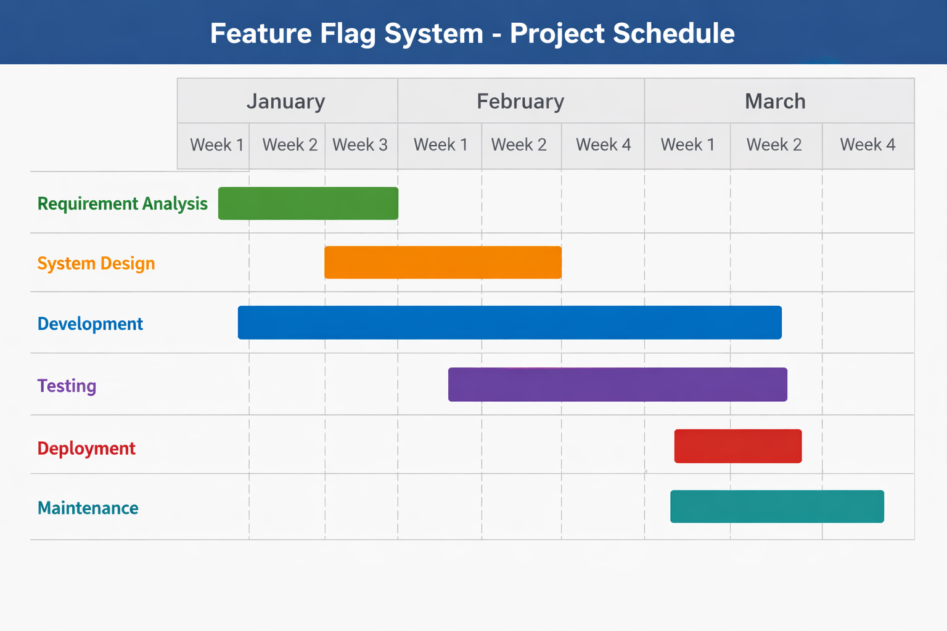

PERT CHART
The PERT (Program Evaluation and Review Technique) chart represents the sequence and dependency of activities involved in the development of the Feature Flag System. It helps in identifying the order of tasks and estimating the time required to complete the project.
The project starts with Requirement Analysis, which is the first step to understand the system needs. After that, the process moves to System Design, where the architecture and database structure are planned. Once the design is completed, the next phase is Development, where the actual coding is done using Spring Boot, PostgreSQL, and Redis.
After development, the project enters the Testing phase, where all functionalities are checked to ensure the system works correctly. Once testing is completed successfully, the system is moved to the Deployment phase, where it is executed using Docker. Finally, the project reaches the Maintenance phase, where improvements, bug fixes, and future enhancements are carried out.
The PERT chart shows that each phase depends on the completion of the previous phase, forming a clear and structured workflow for the project.

SYSTEM ANALYSIS
IDENTIFICATION OF NEED
In modern software development, there is a growing need for systems that allow flexible and real-time control over application features. Traditional methods require code changes and redeployment to enable or disable features, which is time-consuming and risky. This can lead to system downtime and affect user experience.
There is also a need to improve system performance, as frequent database access can slow down applications and increase load. Additionally, organizations require a safe way to test new features without impacting all users at once.
Therefore, a Feature Flag System is needed to provide dynamic feature control, improve performance using caching, reduce risk, and support efficient and scalable application management
• Dynamic feature control
• No redeployment required
• Reduced system risk
• Improved performance
• Faster response time
• Reduced database load
• Real-time updates
• Better user experience
• Scalable system design

In other words, identification of need refers to the process of understanding the limitations and problems present in existing systems and recognizing the requirements for improvement. In traditional software development, managing application features is often a complex and time-consuming task. Developers are required to modify the code and redeploy the application whenever a new feature is introduced or an existing feature needs to be updated. This not only increases development time but also introduces a higher risk of system failure, especially if the new changes contain bugs.
Additionally, continuous interaction with the database for every request can lead to performance issues, increased response time, and higher server load. This makes the system less efficient and affects the overall user experience. There is also a lack of flexibility in controlling features dynamically, which makes it difficult to test new functionalities or roll back changes quickly in case of errors.
Therefore, there is a clear need for a system that allows dynamic control of features without requiring code changes or redeployment. Such a system should also improve performance by reducing database load through caching techniques and ensure faster response time. It should provide flexibility, scalability, and reliability, making it suitable for modern applications.
Thus, identification of need highlights the importance of developing a Feature Flag System that can address these challenges and provide an efficient, flexible, and high-performing solution.

FEASIBILITY STUDY

The feasibility study of the Feature Flag System evaluates whether the project is practical, achievable, and beneficial. It includes technical, economic, and operational feasibility.
Technical:
The Feature Flag System is technically feasible as it is developed using modern and widely adopted technologies such as Java, Spring Boot, PostgreSQL, Redis, and Docker. These technologies are well-documented, reliable, and commonly used in the software industry, making development and implementation easier. The backend is built using Spring Boot, which provides a scalable and robust framework for creating RESTful APIs. PostgreSQL is used for structured data storage, while Redis is integrated as a caching layer to enhance system performance by reducing database load.
The system can be implemented on standard hardware without requiring high-end resources, making it accessible and practical. Integration between different components such as backend services, database, and cache is smooth and efficient. Docker is used to containerize the application, ensuring consistent deployment across different environments.
Additionally, the project does not require any specialized tools or complex configurations, which makes it easy to develop, test, and maintain. The availability of community support and documentation further ensures that any technical challenges can be resolved quickly. Therefore, the project is highly feasible from a technical perspective.

Economic:
The Feature Flag System is economically feasible as it is developed using open-source technologies such as Java, Spring Boot, PostgreSQL, Redis, and Docker. These tools do not require any licensing cost, which significantly reduces the overall development expense.
The hardware requirements for the system are minimal, and it can run on a standard computer, eliminating the need for costly infrastructure. Additionally, the use of Redis caching reduces database load, which can lower server and maintenance costs in real-world applications.
The development and maintenance of the system do not require a large team or high investment, making it cost-effective. Overall, the project provides high value with low cost, making it economically viable and suitable for practical implementation.

Operational:
The Feature Flag System is operationally feasible as it is simple to use and easy to manage. The system allows administrators or developers to enable or disable features in real time without modifying the code or redeploying the application. This makes the operation fast and efficient.
The system improves overall performance by using Redis caching, which provides quick responses and reduces database load. It also minimizes system risk by allowing features to be turned OFF instantly if any issue occurs.
The user interface and APIs are easy to understand, making it convenient for users to operate the system without requiring advanced technical knowledge. Additionally, the system supports smooth integration with existing applications.
Overall, the system is reliable, user-friendly, and efficient in real-world operations.

DFD
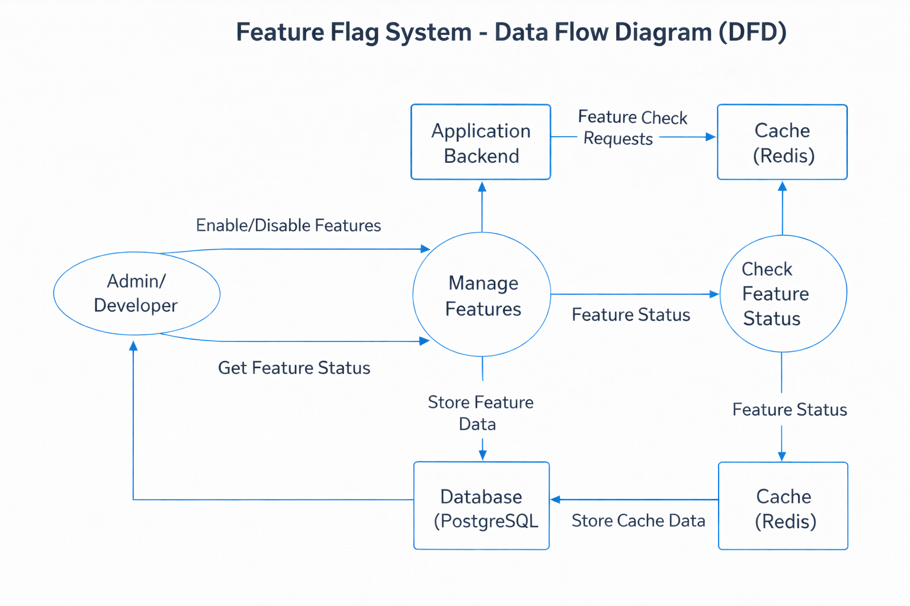

MODULE DESCRIPTION

These are the following Modules in the project:-

- Admin/Developer Module
This module allows administrators or developers to manage feature flags. They can create, update, enable, or disable features using API requests. It provides control over application behavior without modifying the code or redeploying the system, ensuring flexibility and real-time feature management.
- Feature Management Module
This module handles the core logic of creating and managing feature flags. It processes requests received from the admin, updates feature status, and ensures correct data flow between backend, database, and cache. It acts as the central control point of the system.
- Backend Processing Module
This module is built using Spring Boot and processes all incoming requests. It checks feature status, communicates with Redis and PostgreSQL, and returns responses to users. It ensures smooth integration of all components and handles business logic efficiently.
- Redis Cache Module
This module is responsible for caching frequently accessed feature data in memory. It provides fast data retrieval and reduces database load. When a request is received, the system first checks Redis before accessing the database, improving performance and response time.
- Database Module (PostgreSQL)
This module stores feature flag data permanently. It maintains records of all features and their statuses. When data is not found in Redis, the system fetches it from the database. It ensures data consistency, reliability, and long-term storage.
- API Module
This module provides REST APIs for creating, updating, and retrieving feature flags. It allows communication between frontend or tools like Postman and the backend. It ensures proper data exchange and enables real-time interaction with the system.

SNAP SHOT

Dashboard-
The project dashboard snapshot represents the user interface or API response view of the Feature Flag System. It shows the list of feature flags along with their current status (ON/OFF). The dashboard allows users or administrators to easily monitor, create, and update features in real time. It provides a clear and organized view of all feature configurations, helping in better management and control of application behavior efficiently.

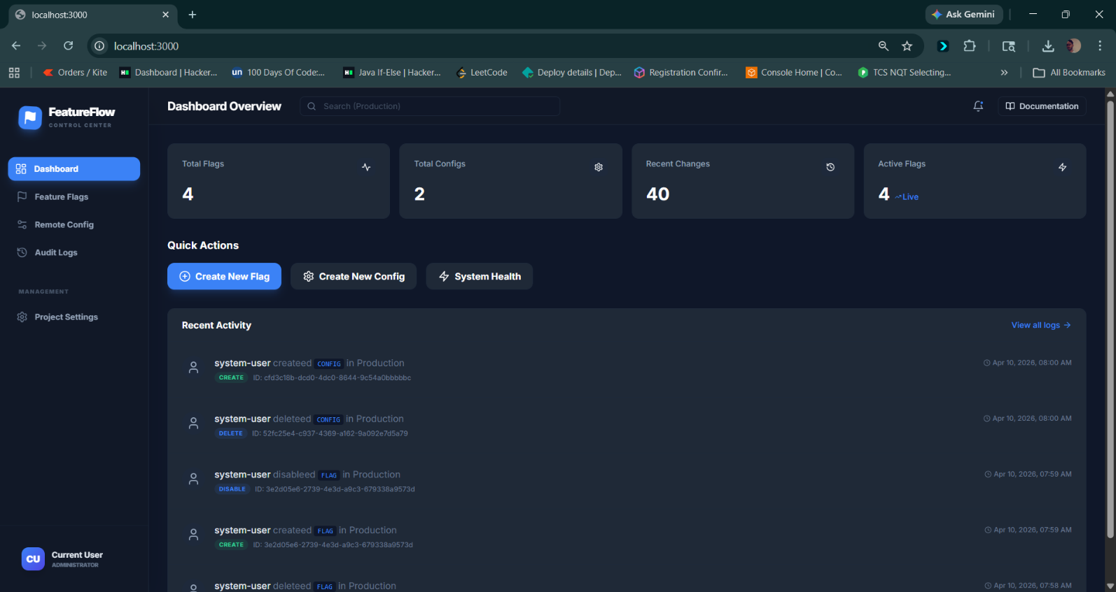
Controller

Flagcontroller.java

package com.devtool.featureflag.controller;
import com.devtool.featureflag.model.Flag;
import com.devtool.featureflag.service.FlagService;
import lombok.RequiredArgsConstructor;
import org.springframework.data.domain.Page;
import org.springframework.data.domain.Pageable;
import org.springframework.http.ResponseEntity;
import org.springframework.web.bind.annotation.*;
import java.util.UUID;
@RestController
@RequestMapping("/api/flags")
@RequiredArgsConstructor
@CrossOrigin(origins = "*")
public class FlagController {
private final FlagService flagService;
@GetMapping
public Page<Flag> getAllFlags(Pageable pageable) {
return flagService.getAllFlags(pageable);
}
@GetMapping("/{id}")
public ResponseEntity<Flag> getFlag(@PathVariable UUID id) {
return ResponseEntity.ok(flagService.getFlag(id));
}
@GetMapping("/key/{key}")
public ResponseEntity<Flag> getFlagByKey(@PathVariable String key) {
return ResponseEntity.ok(flagService.getFlagByKey(key));
}
@PostMapping
public ResponseEntity<Flag> createFlag(@RequestBody Flag flag) {
// userId should ideally come from security context
return ResponseEntity.ok(flagService.createFlag(flag, "system-user"));
}
@PutMapping("/{id}")
public ResponseEntity<Flag> updateFlag(@PathVariable UUID id, @RequestBody Flag flag) {
return ResponseEntity.ok(flagService.updateFlag(id, flag, "system-user"));
}
@DeleteMapping("/{id}")
public ResponseEntity<Void> deleteFlag(@PathVariable UUID id) {
flagService.deleteFlag(id, "system-user");
return ResponseEntity.noContent().build();
}
@PostMapping("/{id}/toggle")
public ResponseEntity<Flag> toggleFlag(@PathVariable UUID id) {
return ResponseEntity.ok(flagService.toggleFlag(id, "system-user"));
}
}

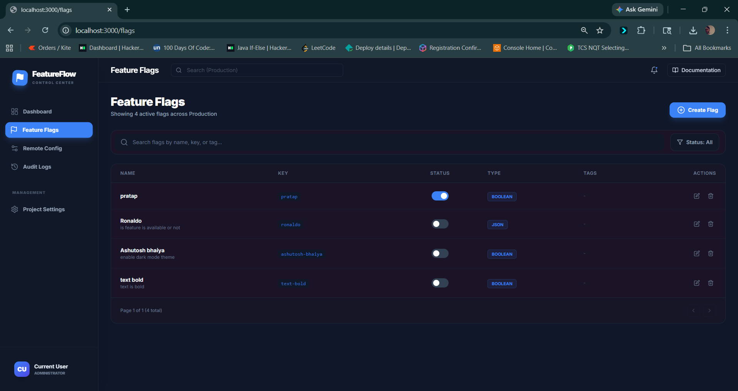

Flaggraphqlcontroller.java

package com.devtool.featureflag.controller;
import com.devtool.featureflag.model.Flag;
import com.devtool.featureflag.service.FlagService;
import lombok.RequiredArgsConstructor;
import org.springframework.data.domain.Page;
import org.springframework.data.domain.PageRequest;
import org.springframework.graphql.data.method.annotation.Argument;
import org.springframework.graphql.data.method.annotation.MutationMapping;
import org.springframework.graphql.data.method.annotation.QueryMapping;
import org.springframework.stereotype.Controller;
import java.util.UUID;
@Controller
@RequiredArgsConstructor
public class FlagGraphQlController {
private final FlagService flagService;
@QueryMapping
public Page<Flag> flags(@Argument int page, @Argument int size) {
return flagService.getAllFlags(PageRequest.of(page, size > 0 ? size : 10));
}
@QueryMapping
public Flag flag(@Argument String id, @Argument String key) {
if (id != null) {
return flagService.getFlag(UUID.fromString(id));
}
if (key != null) {
return flagService.getFlagByKey(key);
}
return null;
}
@MutationMapping
public Flag toggleFlag(@Argument String id) {
return flagService.toggleFlag(UUID.fromString(id), "graphql-user");
}
}

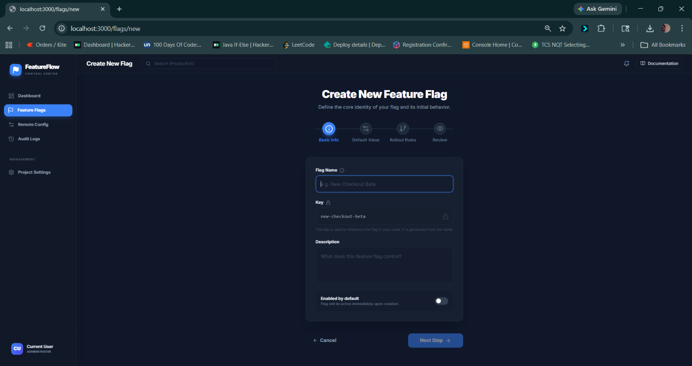

Auditcontroller.java

package com.devtool.featureflag.controller;
import com.devtool.featureflag.model.AuditLog;
import com.devtool.featureflag.repository.AuditLogRepository;
import lombok.RequiredArgsConstructor;
import org.springframework.data.domain.Page;
import org.springframework.data.domain.Pageable;
import org.springframework.web.bind.annotation.*;
import java.util.UUID;
@RestController
@RequestMapping("/api/audit")
@RequiredArgsConstructor
@CrossOrigin(origins = "*")
public class AuditController {
private final AuditLogRepository auditLogRepository;
@GetMapping
public Page<AuditLog> getAllLogs(Pageable pageable) {
return auditLogRepository.findAll(pageable);
}
@GetMapping("/entity/{type}/{id}")
public Page<AuditLog> getLogsForEntity(@PathVariable String type, @PathVariable UUID id, Pageable pageable) {
return auditLogRepository.findByEntityTypeAndEntityIdOrderByCreatedAtDesc(type, id, pageable);
}
}

AuditGraphQLcontroller.java

package com.devtool.featureflag.controller;
import com.devtool.featureflag.model.AuditLog;
import com.devtool.featureflag.repository.AuditLogRepository;
import lombok.RequiredArgsConstructor;
import org.springframework.data.domain.Page;
import org.springframework.data.domain.PageRequest;
import org.springframework.graphql.data.method.annotation.Argument;
import org.springframework.graphql.data.method.annotation.QueryMapping;
import org.springframework.stereotype.Controller;
@Controller
@RequiredArgsConstructor
public class AuditGraphQlController {
private final AuditLogRepository auditLogRepository;
@QueryMapping
public Page<AuditLog> auditLogs(@Argument int page, @Argument int size) {
return auditLogRepository.findAll(PageRequest.of(page, size > 0 ? size : 10));
}
}

ConfigController.java
package com.devtool.featureflag.controller;
import com.devtool.featureflag.model.Config;
import com.devtool.featureflag.service.ConfigService;
import lombok.RequiredArgsConstructor;
import org.springframework.data.domain.Page;
import org.springframework.data.domain.Pageable;
import org.springframework.http.ResponseEntity;
import org.springframework.web.bind.annotation.*;
import java.util.UUID;
@RestController
@RequestMapping("/api/configs")
@RequiredArgsConstructor
@CrossOrigin(origins = "*")
public class ConfigController {
private final ConfigService configService;
@GetMapping
public Page<Config> getAllConfigs(Pageable pageable) {
return configService.getAllConfigs(pageable);
}
@GetMapping("/{id}")
public ResponseEntity<Config> getConfigById(@PathVariable UUID id) {
return ResponseEntity.ok(configService.getConfigById(id));
}
@GetMapping("/key/{key}")
public ResponseEntity<Config> getConfigByKey(@PathVariable String key) {
return ResponseEntity.ok(configService.getConfigByKey(key));
}
@PostMapping
public ResponseEntity<Config> createConfig(@RequestBody Config config) {
return ResponseEntity.ok(configService.createConfig(config, "system-user"));
}
@PutMapping("/{id}")
public ResponseEntity<Config> updateConfig(@PathVariable UUID id, @RequestBody Config config) {
return ResponseEntity.ok(configService.updateConfig(id, config, "system-user"));
}
@DeleteMapping("/{id}")
public ResponseEntity<Void> deleteConfig(@PathVariable UUID id) {
configService.deleteConfig(id, "system-user");
return ResponseEntity.noContent().build();
}
}

ConfigGraphcontroller.java

package com.devtool.featureflag.controller;
import com.devtool.featureflag.model.Config;
import com.devtool.featureflag.service.ConfigService;
import com.fasterxml.jackson.databind.JsonNode;
import com.fasterxml.jackson.databind.ObjectMapper;
import lombok.RequiredArgsConstructor;
import org.springframework.data.domain.Page;
import org.springframework.data.domain.PageRequest;
import org.springframework.graphql.data.method.annotation.Argument;
import org.springframework.graphql.data.method.annotation.MutationMapping;
import org.springframework.graphql.data.method.annotation.QueryMapping;
import org.springframework.stereotype.Controller;
@Controller
@RequiredArgsConstructor
public class ConfigGraphQlController {
private final ConfigService configService;
private final ObjectMapper objectMapper;
@QueryMapping
public Page<Config> configs(@Argument int page, @Argument int size) {
return configService.getAllConfigs(PageRequest.of(page, size > 0 ? size : 10));
}
@QueryMapping
public Config config(@Argument String key) {
return configService.getConfigByKey(key);
}
@MutationMapping
public Config updateConfig(@Argument String key, @Argument String value) {
try {
Config config = configService.getConfigByKey(key);
// Try to parse as JSON, if it fails, treat as a JSON String
JsonNode jsonValue;
try {
jsonValue = objectMapper.readTree(value);
} catch (Exception e) {
jsonValue = objectMapper.valueToTree(value);
}
config.setValue(jsonValue);
return configService.updateConfig(config.getId(), config, "graphql-user");
} catch (Exception e) {
throw new RuntimeException("Failed to update config: " + e.getMessage());
}
}
}

LIST OF REPORTS

The following reports will be generated:-

- Feature Flag Status Report
- Feature Flag Usage Report
- User Activity Report
- Access Control / Role-Based Report
- Change History (Audit) Report
- System Performance Report
- Error and Exception Report
- Deployment Report
- Environment-wise Feature Report (Dev, Test, Production)
- Active vs Inactive Feature Report

SCOPE AND FUTURE ENHANCEMENT

The scope of the Feature Flag System is to provide dynamic control over application features in real time without requiring code changes or redeployment. It can be used in various types of applications such as web applications, mobile apps, and enterprise systems to manage features efficiently. The system improves performance, reduces risk, and supports safe feature deployment in production environments.
In the future, several enhancements can be added to make the system more powerful and user-friendly. A graphical dashboard can be developed to provide a better user interface for managing feature flags. Percentage-based rollout can be implemented to release features gradually to a specific group of users. User-based targeting can also be added to enable features for selected users only.
Additional features such as role-based access control, logging and monitoring, and integration with cloud platforms can further improve the system. These enhancements will make the Feature Flag System more scalable, secure, and suitable for real-world industry applications.

IMPLEMENTATION METHODOLOGY

The implementation of the Feature Flag System follows a structured approach using modern backend technologies. Initially, the project setup is done using Spring Boot, and the required dependencies are added using Maven. The database schema is designed in PostgreSQL to store feature flag details such as name and status.
Next, the backend is developed by creating different layers, including Controller, Service, Repository, and Entity. The Controller handles API requests, the Service contains business logic, and the Repository interacts with the database. Redis is integrated as a caching layer to store frequently accessed feature data, improving system performance.
REST APIs are created to allow users to create, update, and retrieve feature flags. The system is tested using Postman to ensure correct functionality. Finally, Docker is used to containerize the application, making deployment easy and consistent across environments. This methodology ensures scalability, performance, and efficient feature management.

TESTING

Software testing consists of the following stages.

TEST PLAN DEVELOPMENT:-

The test plan for the Feature Flag System is developed to ensure that all functionalities work correctly and efficiently. It includes testing of API endpoints for creating, updating, and retrieving feature flags. Different test cases are designed to verify feature ON/OFF behavior, data accuracy, and system performance. Redis caching is also tested to ensure fast response and reduced database load. Tools like Postman are used for API testing. Both positive and negative test cases are considered to check system reliability. The test plan helps in identifying bugs, ensuring quality, and delivering a stable and reliable application.

TESTING STRATEGY:-
The testing strategy for the Feature Flag System focuses on ensuring accuracy, performance, and reliability. Unit testing is performed to verify individual components such as controller, service, and repository layers. Integration testing is conducted to ensure proper communication between backend, Redis cache, and PostgreSQL database.
API testing is done using Postman to validate request and response behavior. Both positive and negative test cases are used to check system stability. Performance testing is carried out to verify fast response using Redis caching. Additionally, error handling and edge cases are tested to ensure the system works correctly under all conditions.

UNIT TESTING:-
Unit testing is an important part of the testing process in the Feature Flag System. It focuses on testing individual components or units of the application, such as the controller, service, and repository layers. The main objective of unit testing is to ensure that each module works correctly in isolation.

In this project, unit testing is performed to verify the functionality of feature creation, update, and retrieval. Each method in the service layer is tested with different inputs to check whether it returns the expected output. Mocking techniques are used to simulate dependencies like database and Redis, so that the unit can be tested independently.

Unit testing helps in identifying bugs at an early stage of development, reducing the chances of errors in the final system. It also improves code quality and makes the application more reliable. By ensuring that each component functions correctly, unit testing contributes to building a stable and maintainable Feature Flag System

INTEGRATION TESTING:-

Integration testing is performed to verify that different modules of the Feature Flag System work correctly together. It focuses on testing the interaction between components such as the controller, service layer, Redis cache, and PostgreSQL database.
In this project, integration testing ensures that when a request is sent to the API, it flows properly through all layers and returns the correct response. It also checks whether data is correctly fetched from the database and stored or retrieved from Redis cache.
This type of testing helps identify issues related to data flow, communication, and system integration. It ensures that all components are properly connected and functioning as a complete system, improving overall reliability and performance.

VALIDATION TESTING:-

Validation testing is performed to ensure that the Feature Flag System meets the user requirements and works as expected in real-world scenarios. It focuses on checking whether the system performs the intended functions correctly, such as enabling or disabling features based on the feature flag status.
In this project, validation testing verifies that when a feature flag is set to ON, the feature is accessible, and when it is OFF, the feature is restricted. It also checks API responses, data accuracy, and system behavior under different conditions.
This testing ensures that the final system is user-friendly, reliable, and fulfills all functional requirements, providing confidence that the system works correctly before deployment

LIMITATIONS AND FURTHER ENHANCEMENTS

LIMITATIONS:
The Feature Flag Management System has some limitations. The system is highly dependent on the backend server, so if the server goes down, feature flags may not work properly and users may face issues. It also has limited real-time performance because changes in feature flags may take some time to reflect across all users or applications. Another limitation is security risk; if proper authentication and authorization are not implemented, unauthorized users may change feature configurations, which can affect the system behavior. The system may also face scalability issues when a large number of users or applications are connected, which can reduce performance. Managing a large number of feature flags can become complex and confusing for users. In addition, the system requires a stable internet connection to function properly, which makes it dependent on network availability.

RECOMMENDED AREAS FOR FURTHER RESEARCH

The Feature Flag Management System has several recommended areas for further research. One important area is improving real-time update mechanisms so that feature flag changes can be reflected instantly across all users without delay. Another area is enhancing security using advanced authentication methods like multi-factor authentication and role-based access control to prevent unauthorized changes. Research can also be done on improving system scalability to handle a large number of users and applications efficiently without performance issues. Integration with artificial intelligence can be explored to automatically manage and optimize feature flags based on user behavior and system performance. Another area is developing better analytics and reporting tools to track the impact of feature flags on user experience. Offline support and caching mechanisms can also be researched so that the system works smoothly even with poor internet connectivity

SECURITY MECHANISM

The Feature Flag Management System uses different security mechanisms to protect data and control access to features. One important mechanism is authentication, which ensures that only valid users can log into the system using username and password. After authentication, authorization is used to control user permissions, meaning only admin users can create, update, or delete feature flags while normal users have limited access.

Another important mechanism is Role-Based Access Control (RBAC), which assigns specific roles like admin, developer, or tester to users and restricts actions based on their roles. The system can also use encryption to protect sensitive data while storing and transferring it, ensuring that information cannot be read by unauthorized users.

Additionally, secure APIs (using JWT tokens or OAuth) help in verifying requests between frontend and backend. Logging and monitoring are also used to track all activities, so any unauthorized access or suspicious activity can be detected easily.

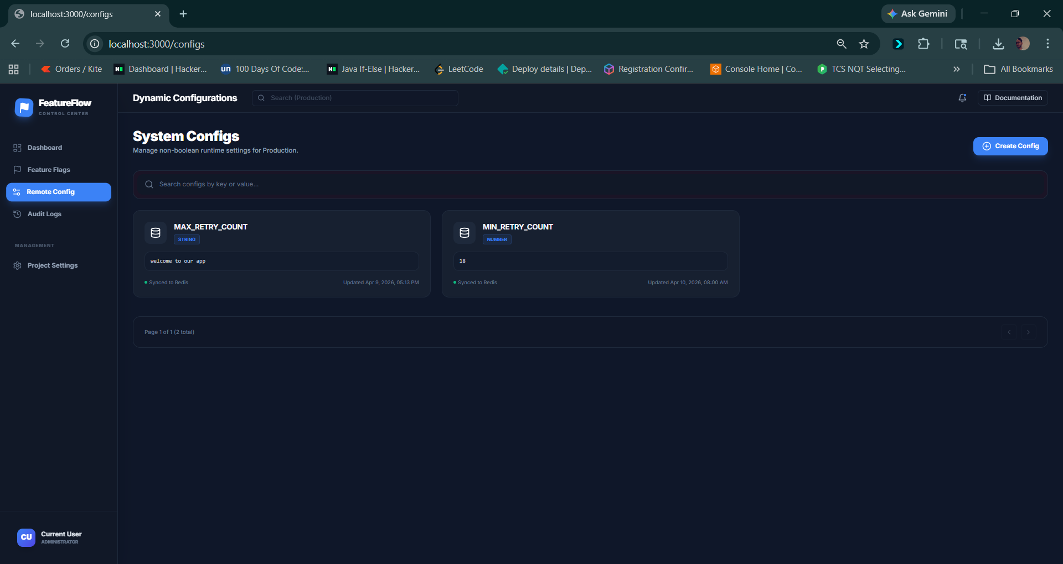
SNAPSHOTS

AsyncConfig.java

package com.devtool.featureflag.config;
import org.springframework.context.annotation.Configuration;
import org.springframework.scheduling.annotation.AsyncConfigurer;
import org.springframework.scheduling.concurrent.ThreadPoolTaskExecutor;
import java.util.concurrent.Executor;
@Configuration
public class AsyncConfig implements AsyncConfigurer {
@Override
public Executor getAsyncExecutor() {
ThreadPoolTaskExecutor executor = new ThreadPoolTaskExecutor();
executor.setCorePoolSize(5);
executor.setMaxPoolSize(10);
executor.setQueueCapacity(100);
executor.setThreadNamePrefix("FF-Async-");
executor.initialize();
return executor;
}
}

RedisConfig.java

package com.devtool.featureflag.config;
import com.fasterxml.jackson.annotation.JsonAutoDetect;
import com.fasterxml.jackson.annotation.PropertyAccessor;
import com.fasterxml.jackson.databind.ObjectMapper;
import com.fasterxml.jackson.databind.SerializationFeature;
import com.fasterxml.jackson.databind.jsontype.impl.LaissezFaireSubTypeValidator;
import com.fasterxml.jackson.datatype.jsr310.JavaTimeModule;
import org.springframework.context.annotation.Bean;
import org.springframework.context.annotation.Configuration;
import org.springframework.data.redis.connection.RedisConnectionFactory;
import org.springframework.data.redis.core.RedisTemplate;
import org.springframework.data.redis.serializer.Jackson2JsonRedisSerializer;
import org.springframework.data.redis.serializer.StringRedisSerializer;
@Configuration
public class RedisConfig {
@Bean
public RedisTemplate<String, Object> redisTemplate(RedisConnectionFactory connectionFactory) {
RedisTemplate<String, Object> template = new RedisTemplate<>();
template.setConnectionFactory(connectionFactory);
ObjectMapper om = new ObjectMapper();
om.registerModule(new JavaTimeModule());
om.disable(SerializationFeature.WRITE_DATES_AS_TIMESTAMPS);
om.setVisibility(PropertyAccessor.ALL, JsonAutoDetect.Visibility.ANY);
om.activateDefaultTyping(LaissezFaireSubTypeValidator.instance, ObjectMapper.DefaultTyping.NON_FINAL);
Jackson2JsonRedisSerializer<Object> serializer = new Jackson2JsonRedisSerializer<>(om, Object.class);
template.setKeySerializer(new StringRedisSerializer());
template.setValueSerializer(serializer);
template.setHashKeySerializer(new StringRedisSerializer());
template.setHashValueSerializer(serializer);
template.afterPropertiesSet();
return template;
}
}

StartUpDataSeeder.java

package com.devtool.featureflag.config;
import com.devtool.featureflag.model.AuditLog;
import com.devtool.featureflag.model.Config;
import com.devtool.featureflag.model.Flag;
import com.devtool.featureflag.repository.AuditLogRepository;
import com.devtool.featureflag.repository.ConfigRepository;
import com.devtool.featureflag.repository.FlagRepository;
import com.fasterxml.jackson.databind.ObjectMapper;
import com.fasterxml.jackson.databind.node.ObjectNode;
import lombok.RequiredArgsConstructor;
import lombok.extern.slf4j.Slf4j;
import org.springframework.boot.ApplicationArguments;
import org.springframework.boot.ApplicationRunner;
import org.springframework.stereotype.Component;
import org.springframework.transaction.annotation.Transactional;
import java.util.List;
/**
* Seeds dummy data on first startup when persistence is empty.
*/
@Component
@RequiredArgsConstructor
@Slf4j
public class StartupDataSeeder implements ApplicationRunner {
private static final String SEED_USER_ID = "system-seed";
private static final String SEED_USER_EMAIL = "seed@featureflags.local";
private final FlagRepository flagRepository;
private final ConfigRepository configRepository;
private final AuditLogRepository auditLogRepository;
private final ObjectMapper objectMapper;
@Override
@Transactional
public void run(ApplicationArguments args) {
if (flagRepository.count() > 0 || configRepository.count() > 0) {
log.info("Skipping seed data because records already exist.");
return;
}
List<Flag> flags = seedFlags();
List<Config> configs = seedConfigs();
seedAuditLogs(flags, configs);
log.info(
"Seeded initial data: {} flags, {} configs, {} audit logs.",
flags.size(),
configs.size(),
flags.size() + configs.size()
);
}
private List<Flag> seedFlags() {
Flag maintenanceMode = new Flag();
maintenanceMode.setKey("maintenance_mode");
maintenanceMode.setName("Maintenance Mode");
maintenanceMode.setDescription("Shows maintenance banner and blocks checkout.");
maintenanceMode.setEnabled(false);
maintenanceMode.setFlagType(Flag.FlagType.BOOLEAN);
maintenanceMode.setDefaultValue("false");
maintenanceMode.setTags(new String[]{"ops", "release"});
maintenanceMode.setCreatedBy(SEED_USER_ID);
Flag expressCheckout = new Flag();
expressCheckout.setKey("express_checkout");
expressCheckout.setName("Express Checkout");
expressCheckout.setDescription("Enables one-click checkout experience.");
expressCheckout.setEnabled(true);
expressCheckout.setFlagType(Flag.FlagType.BOOLEAN);
expressCheckout.setDefaultValue("true");
expressCheckout.setTags(new String[]{"checkout", "growth"});
expressCheckout.setCreatedBy(SEED_USER_ID);
Flag newSearch = new Flag();
newSearch.setKey("new_search_v2");
newSearch.setName("Semantic Search V2");
newSearch.setDescription("Rolls out semantic search for the catalog.");
newSearch.setEnabled(false);
newSearch.setFlagType(Flag.FlagType.BOOLEAN);
newSearch.setDefaultValue("false");
newSearch.setTags(new String[]{"search", "experimentation"});
newSearch.setCreatedBy(SEED_USER_ID);
return flagRepository.saveAll(List.of(
maintenanceMode,
expressCheckout,
newSearch
));
}
private List<Config> seedConfigs() {
Config recommendationModel = new Config();
recommendationModel.setKey("recommendation_model");
recommendationModel.setName("Recommendation Model");
recommendationModel.setDescription("Active recommendation model identifier.");
recommendationModel.setValue(objectMapper.getNodeFactory().textNode("baseline-v1"));
recommendationModel.setConfigType("STRING");
recommendationModel.setEnvironment("production");
recommendationModel.setCreatedBy(SEED_USER_ID);
Config checkoutBanner = new Config();
checkoutBanner.setKey("checkout_banner_text");
checkoutBanner.setName("Checkout Banner Text");
checkoutBanner.setDescription("Checkout area message shown to users.");
checkoutBanner.setValue(
objectMapper.getNodeFactory().textNode(
"Free shipping on orders above $50."
)
);
checkoutBanner.setConfigType("STRING");
checkoutBanner.setEnvironment("production");
checkoutBanner.setCreatedBy(SEED_USER_ID);
Config maxCartItems = new Config();
maxCartItems.setKey("max_cart_items");
maxCartItems.setName("Max Cart Items");
maxCartItems.setDescription("Maximum items allowed in user cart.");
maxCartItems.setValue(objectMapper.getNodeFactory().numberNode(20));
maxCartItems.setConfigType("NUMBER");
maxCartItems.setEnvironment("production");
maxCartItems.setCreatedBy(SEED_USER_ID);
return configRepository.saveAll(List.of(
recommendationModel,
checkoutBanner,
maxCartItems
));
}
private void seedAuditLogs(List<Flag> flags, List<Config> configs) {
for (Flag flag : flags) {
AuditLog auditLog = new AuditLog();
auditLog.setEntityType("FLAG");
auditLog.setEntityId(flag.getId());
auditLog.setAction("CREATE");
auditLog.setUserId(SEED_USER_ID);
auditLog.setUserEmail(SEED_USER_EMAIL);
auditLog.setMetadata(seedMetadata("Initial demo flag seeded on startup."));
auditLogRepository.save(auditLog);
}
for (Config config : configs) {
AuditLog auditLog = new AuditLog();
auditLog.setEntityType("CONFIG");
auditLog.setEntityId(config.getId());
auditLog.setAction("CREATE");
auditLog.setUserId(SEED_USER_ID);
auditLog.setUserEmail(SEED_USER_EMAIL);
auditLog.setMetadata(seedMetadata("Initial demo config seeded on startup."));
auditLogRepository.save(auditLog);
}
}
private ObjectNode seedMetadata(String note) {
ObjectNode metadata = objectMapper.createObjectNode();
metadata.put("source", "startup-seeder");
metadata.put("environment", "production");
metadata.put("note", note);
return metadata;
}
}

GlobalExeptionHnadler.java
package com.devtool.featureflag.exception;
import lombok.AllArgsConstructor;
import lombok.Data;
import org.springframework.http.HttpStatus;
import org.springframework.http.ResponseEntity;
import org.springframework.web.bind.annotation.ControllerAdvice;
import org.springframework.web.bind.annotation.ExceptionHandler;
import org.springframework.web.context.request.WebRequest;
import java.time.LocalDateTime;
@ControllerAdvice
public class GlobalExceptionHandler {
@ExceptionHandler(RuntimeException.class)
public ResponseEntity<?> handleRuntimeException(RuntimeException ex, WebRequest request) {
ErrorDetails errorDetails = new ErrorDetails(
LocalDateTime.now(),
ex.getMessage(),
request.getDescription(false));
return new ResponseEntity<>(errorDetails, HttpStatus.INTERNAL_SERVER_ERROR);
}
@ExceptionHandler(Exception.class)
public ResponseEntity<?> handleGlobalException(Exception ex, WebRequest request) {
ErrorDetails errorDetails = new ErrorDetails(
LocalDateTime.now(),
"An unexpected error occurred: " + ex.getMessage(),
request.getDescription(false));
return new ResponseEntity<>(errorDetails, HttpStatus.INTERNAL_SERVER_ERROR);
}
@Data
@AllArgsConstructor
public static class ErrorDetails {
private LocalDateTime timestamp;
private String message;
private String details;
}
}

Flaggrpcservive.java

package com.devtool.featureflag.grpc;
import com.devtool.featureflag.model.Flag;
import com.devtool.featureflag.service.FlagService;
import io.grpc.stub.StreamObserver;
import lombok.RequiredArgsConstructor;
import net.devh.boot.grpc.server.service.GrpcService;
import org.springframework.data.domain.Page;
import org.springframework.data.domain.PageRequest;
import java.util.UUID;
import java.util.stream.Collectors;
@GrpcService
@RequiredArgsConstructor
public class FlagGrpcService extends FeatureFlagServiceGrpc.FeatureFlagServiceImplBase {
private final FlagService flagService;
@Override
public void getFlag(GetFlagRequest request, StreamObserver<FlagResponse> responseObserver) {
Flag flag;
if (!request.getId().isEmpty()) {
flag = flagService.getFlag(UUID.fromString(request.getId()));
} else if (!request.getKey().isEmpty()) {
flag = flagService.getFlagByKey(request.getKey());
} else {
responseObserver.onError(new IllegalArgumentException("ID or Key must be provided"));
return;
}
responseObserver.onNext(mapToResponse(flag));
responseObserver.onCompleted();
}
@Override
public void getAllFlags(GetAllFlagsRequest request, StreamObserver<FlagsPageResponse> responseObserver) {
Page<Flag> page = flagService
.getAllFlags(PageRequest.of(request.getPage(), request.getSize() > 0 ? request.getSize() : 10));
FlagsPageResponse response = FlagsPageResponse.newBuilder()
.addAllContent(page.getContent().stream().map(this::mapToResponse).collect(Collectors.toList()))
.setTotalElements((int) page.getTotalElements())
.setTotalPages(page.getTotalPages())
.build();
responseObserver.onNext(response);
responseObserver.onCompleted();
}
@Override
public void toggleFlag(ToggleFlagRequest request, StreamObserver<FlagResponse> responseObserver) {
Flag flag = flagService.toggleFlag(UUID.fromString(request.getId()),
request.getUserId().isEmpty() ? "grpc-user" : request.getUserId());
responseObserver.onNext(mapToResponse(flag));
responseObserver.onCompleted();
}
private FlagResponse mapToResponse(Flag flag) {
return FlagResponse.newBuilder()
.setId(flag.getId().toString())
.setKey(flag.getKey())
.setName(flag.getName())
.setDescription(flag.getDescription() != null ? flag.getDescription() : "")
.setEnabled(flag.getEnabled())
.setArchived(flag.getArchived())
.setCreatedAt(flag.getCreatedAt().toString())
.setUpdatedAt(flag.getUpdatedAt().toString())
.setVersion(flag.getVersion())
.build();
}
}

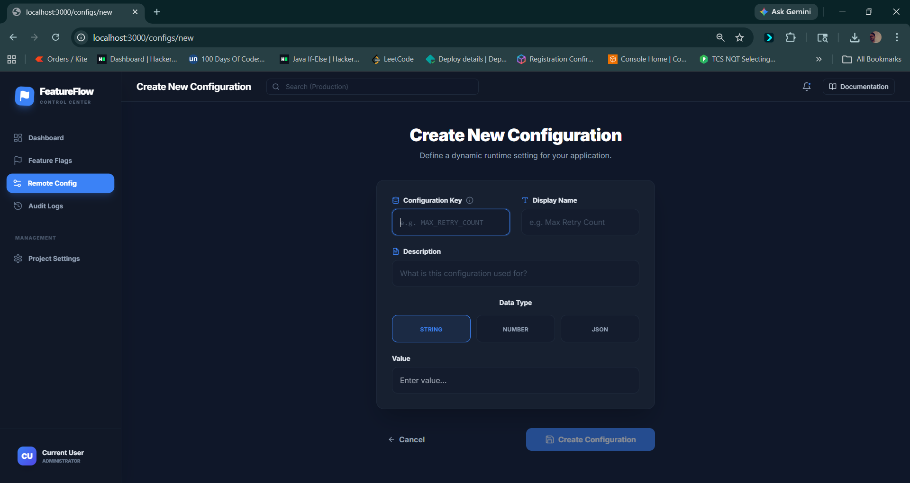

Config.java

package com.devtool.featureflag.grpc;
import com.devtool.featureflag.model.Flag;
import com.devtool.featureflag.service.FlagService;
import io.grpc.stub.StreamObserver;
import ombok.RequiredArgsConstructor;
import net.devh.boot.grpc.server.service.GrpcService;
import org.springframework.data.domain.Page;
import org.springframework.data.domain.PageRequest;
import java.util.UUID;
import java.util.stream.Collectors;
@GrpcService
@RequiredArgsConstructor
public class FlagGrpcService extends FeatureFlagServiceGrpc.FeatureFlagServiceImplBase {
private final FlagService flagService;
@Override
public void getFlag(GetFlagRequest request, StreamObserver<FlagResponse> responseObserver) {
Flag flag;
if (!request.getId().isEmpty()) {
flag = flagService.getFlag(UUID.fromString(request.getId()));
} else if (!request.getKey().isEmpty()) {
flag = flagService.getFlagByKey(request.getKey());
} else {
responseObserver.onError(new IllegalArgumentException(“ID or Key must be provided”));
return;
}
responseObserver.onNext(mapToResponse(flag));
responseObserver.onCompleted();
}
@Override
public void getAllFlags(GetAllFlagsRequest request, StreamObserver<FlagsPageResponse> responseObserver) {
Page<Flag> page = flagService
.getAllFlags(PageRequest.of(request.getPage(), request.getSize() > 0 ? request.getSize() : 10));
FlagsPageResponse response = FlagsPageResponse.newBuilder()
.addAllContent(page.getContent().stream().map(this::mapToResponse).collect(Collectors.toList()))
.setTotalElements((int) page.getTotalElements())
.setTotalPages(page.getTotalPages())
.build();
responseObserver.onNext(response);
responseObserver.onCompleted();
}
@Override
public void toggleFlag(ToggleFlagRequest request, StreamObserver<FlagResponse> responseObserver) {
Flag flag = flagService.toggleFlag(UUID.fromString(request.getId()),
request.getUserId().isEmpty() ? “grpc-user” : request.getUserId());
responseObserver.onNext(mapToResponse(flag));
responseObserver.onCompleted();
}
private FlagResponse mapToResponse(Flag flag) {
return FlagResponse.newBuilder()
.setId(flag.getId().toString())
.setKey(flag.getKey())
.setName(flag.getName())
.setDescription(flag.getDescription() != null ? flag.getDescription() : “”)
.setEnabled(flag.getEnabled())
.setArchived(flag.getArchived())
.setCreatedAt(flag.getCreatedAt().toString())
.setUpdatedAt(flag.getUpdatedAt().toString())
.setVersion(flag.getVersion())
.build();
}
}

StartConfig.java

package com.devtool.featureflag.config;
import com.devtool.featureflag.model.AuditLog;
import com.devtool.featureflag.model.Config;
import com.devtool.featureflag.model.Flag;
import com.devtool.featureflag.repository.AuditLogRepository;
import com.devtool.featureflag.repository.ConfigRepository;
import com.devtool.featureflag.repository.FlagRepository;
import com.fasterxml.jackson.databind.ObjectMapper;
import com.fasterxml.jackson.databind.node.ObjectNode;
import lombok.RequiredArgsConstructor;
import lombok.extern.slf4j.Slf4j;
import org.springframework.boot.ApplicationArguments;
import org.springframework.boot.ApplicationRunner;
import org.springframework.stereotype.Component;
import org.springframework.transaction.annotation.Transactional;
import java.util.List;
/**
* Seeds dummy data on first startup when persistence is empty.
*/
@Component
@RequiredArgsConstructor
@Slf4j
public class StartupDataSeeder implements ApplicationRunner {
private static final String SEED_USER_ID = "system-seed";
private static final String SEED_USER_EMAIL = "seed@featureflags.local";
private final FlagRepository flagRepository;
private final ConfigRepository configRepository;
private final AuditLogRepository auditLogRepository;
private final ObjectMapper objectMapper;
@Override
@Transactional
public void run(ApplicationArguments args) {
if (flagRepository.count() > 0 || configRepository.count() > 0) {
log.info("Skipping seed data because records already exist.");
return;
}
List<Flag> flags = seedFlags();
List<Config> configs = seedConfigs();
seedAuditLogs(flags, configs);
log.info(
"Seeded initial data: {} flags, {} configs, {} audit logs.",
flags.size(),
configs.size(),
flags.size() + configs.size()
);
}
private List<Flag> seedFlags() {
Flag maintenanceMode = new Flag();
maintenanceMode.setKey("maintenance_mode");
maintenanceMode.setName("Maintenance Mode");
maintenanceMode.setDescription("Shows maintenance banner and blocks checkout.");
maintenanceMode.setEnabled(false);
maintenanceMode.setFlagType(Flag.FlagType.BOOLEAN);
maintenanceMode.setDefaultValue("false");
maintenanceMode.setTags(new String[]{"ops", "release"});
maintenanceMode.setCreatedBy(SEED_USER_ID);
Flag expressCheckout = new Flag();
expressCheckout.setKey("express_checkout");
expressCheckout.setName("Express Checkout");
expressCheckout.setDescription("Enables one-click checkout experience.");
expressCheckout.setEnabled(true);
expressCheckout.setFlagType(Flag.FlagType.BOOLEAN);
expressCheckout.setDefaultValue("true");
expressCheckout.setTags(new String[]{"checkout", "growth"});
expressCheckout.setCreatedBy(SEED_USER_ID);
Flag newSearch = new Flag();
newSearch.setKey("new_search_v2");
newSearch.setName("Semantic Search V2");
newSearch.setDescription("Rolls out semantic search for the catalog.");
newSearch.setEnabled(false);
newSearch.setFlagType(Flag.FlagType.BOOLEAN);
newSearch.setDefaultValue("false");
newSearch.setTags(new String[]{"search", "experimentation"});
newSearch.setCreatedBy(SEED_USER_ID);
return flagRepository.saveAll(List.of(
maintenanceMode,
expressCheckout,
newSearch
));
}
private List<Config> seedConfigs() {
Config recommendationModel = new Config();
recommendationModel.setKey("recommendation_model");
recommendationModel.setName("Recommendation Model");
recommendationModel.setDescription("Active recommendation model identifier.");
recommendationModel.setValue(objectMapper.getNodeFactory().textNode("baseline-v1"));
recommendationModel.setConfigType("STRING");
recommendationModel.setEnvironment("production");
recommendationModel.setCreatedBy(SEED_USER_ID);
Config checkoutBanner = new Config();
checkoutBanner.setKey("checkout_banner_text");
checkoutBanner.setName("Checkout Banner Text");
checkoutBanner.setDescription("Checkout area message shown to users.");
checkoutBanner.setValue(
objectMapper.getNodeFactory().textNode(
"Free shipping on orders above $50."
)
);
checkoutBanner.setConfigType("STRING");
checkoutBanner.setEnvironment("production");
checkoutBanner.setCreatedBy(SEED_USER_ID);
Config maxCartItems = new Config();
maxCartItems.setKey("max_cart_items");
maxCartItems.setName("Max Cart Items");
maxCartItems.setDescription("Maximum items allowed in user cart.");
maxCartItems.setValue(objectMapper.getNodeFactory().numberNode(20));
maxCartItems.setConfigType("NUMBER");
maxCartItems.setEnvironment("production");
maxCartItems.setCreatedBy(SEED_USER_ID);
return configRepository.saveAll(List.of(
recommendationModel,
checkoutBanner,
maxCartItems
));
}
private void seedAuditLogs(List<Flag> flags, List<Config> configs) {
for (Flag flag : flags) {
AuditLog auditLog = new AuditLog();
auditLog.setEntityType("FLAG");
auditLog.setEntityId(flag.getId());
auditLog.setAction("CREATE");
auditLog.setUserId(SEED_USER_ID);
auditLog.setUserEmail(SEED_USER_EMAIL);
auditLog.setMetadata(seedMetadata("Initial demo flag seeded on startup."));
auditLogRepository.save(auditLog);
}
for (Config config : configs) {
AuditLog auditLog = new AuditLog();
auditLog.setEntityType("CONFIG");
auditLog.setEntityId(config.getId());
auditLog.setAction("CREATE");
auditLog.setUserId(SEED_USER_ID);
auditLog.setUserEmail(SEED_USER_EMAIL);
auditLog.setMetadata(seedMetadata("Initial demo config seeded on startup."));
auditLogRepository.save(auditLog);
}
}
private ObjectNode seedMetadata(String note) {
ObjectNode metadata = objectMapper.createObjectNode();
metadata.put("source", "startup-seeder");
metadata.put("environment", "production");
metadata.put("note", note);
return metadata;
}
}

config.java

package com.devtool.featureflag.model;
import com.fasterxml.jackson.databind.JsonNode;
import jakarta.persistence.*;
import lombok.Data;
import org.hibernate.annotations.CreationTimestamp;
import org.hibernate.annotations.JdbcTypeCode;
import org.hibernate.annotations.UpdateTimestamp;
import org.hibernate.type.SqlTypes;
import java.time.LocalDateTime;
import java.util.UUID;
@Entity
@Table(name = "configs")
@Data
public class Config {
@Id
@GeneratedValue(strategy = GenerationType.UUID)
private UUID id;
@Column(unique = true, nullable = false)
private String key;
@Column(nullable = false)
private String name;
private String description;
@JdbcTypeCode(SqlTypes.JSON)
@Column(columnDefinition = "jsonb", nullable = false)
private JsonNode value;
private String configType = "JSON";
private String environment = "production";
@CreationTimestamp
private LocalDateTime createdAt;
@UpdateTimestamp
private LocalDateTime updatedAt;
private String createdBy;
private Integer version = 1;
}
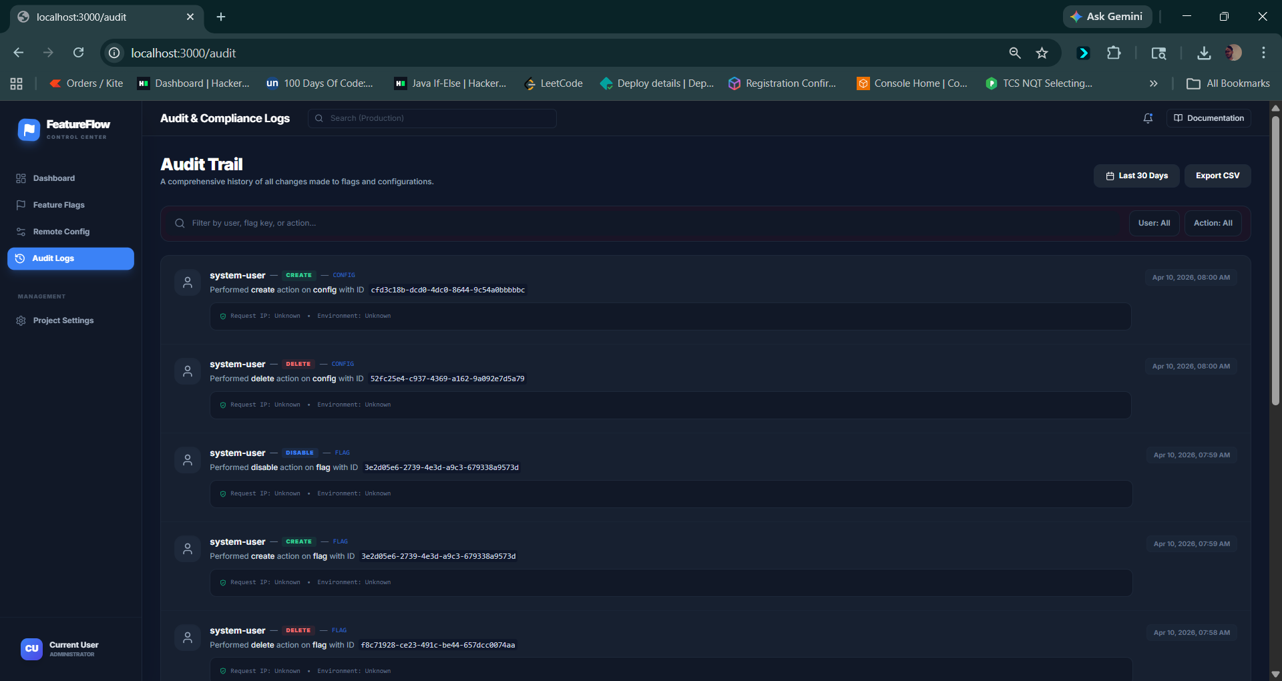

Auditlog.java

package com.devtool.featureflag.model;
import com.fasterxml.jackson.databind.JsonNode;
import jakarta.persistence.*;
import lombok.Data;
import org.hibernate.annotations.CreationTimestamp;
import org.hibernate.annotations.JdbcTypeCode;
import org.hibernate.type.SqlTypes;
import java.time.LocalDateTime;
import java.util.UUID;
@Entity
@Table(name = "audit_logs")
@Data
public class AuditLog {
@Id
@GeneratedValue(strategy = GenerationType.UUID)
private UUID id;
@Column(nullable = false)
private String entityType;
@Column(nullable = false)
private UUID entityId;
@Column(nullable = false)
private String action;
private String userId;
private String userEmail;
@JdbcTypeCode(SqlTypes.JSON)
@Column(columnDefinition = "jsonb")
private JsonNode changes;
@JdbcTypeCode(SqlTypes.JSON)
@Column(columnDefinition = "jsonb")
private JsonNode metadata;
private String ipAddress;
private String userAgent;
@CreationTimestamp
private LocalDateTime createdAt;
}

Flag.java

package com.devtool.featureflag.model;
import jakarta.persistence.*;
import lombok.Data;
import org.hibernate.annotations.CreationTimestamp;
import org.hibernate.annotations.UpdateTimestamp;
import java.time.LocalDateTime;
import java.util.ArrayList;
import java.util.List;
import java.util.UUID;
@Entity
@Table(name = "flags")
@Data
public class Flag {
@Id
@GeneratedValue(strategy = GenerationType.UUID)
private UUID id;
@Column(unique = true, nullable = false)
private String key;
@Column(nullable = false)
private String name;
private String description;
private Boolean enabled = false;
@Enumerated(EnumType.STRING)
private FlagType flagType = FlagType.BOOLEAN;
private String defaultValue;
@CreationTimestamp
private LocalDateTime createdAt;
@UpdateTimestamp
private LocalDateTime updatedAt;
private String createdBy;
@Column(name = "tags", columnDefinition = "text[]")
private String[] tags;
private Boolean archived = false;
@OneToMany(mappedBy = "flag", cascade = CascadeType.ALL, orphanRemoval = true)
private List<RolloutRule> rolloutRules = new ArrayList<>();
private Integer version = 1;
public enum FlagType {
BOOLEAN, STRING, NUMBER, JSON
}
}

DB migration

-- V1__initial_schema.sql
-- Feature Flags Table
CREATE TABLE flags (
id UUID PRIMARY KEY DEFAULT gen_random_uuid(),
key VARCHAR(255) UNIQUE NOT NULL,
name VARCHAR(255) NOT NULL,
description TEXT,
enabled BOOLEAN DEFAULT false,
flag_type VARCHAR(50) DEFAULT 'BOOLEAN', -- BOOLEAN, STRING, NUMBER, JSON
default_value TEXT,
created_at TIMESTAMP DEFAULT CURRENT_TIMESTAMP,
updated_at TIMESTAMP DEFAULT CURRENT_TIMESTAMP,
created_by VARCHAR(255),
tags TEXT[], -- Array of tags for organization
archived BOOLEAN DEFAULT false
);
CREATE INDEX idx_flags_key ON flags(key);
CREATE INDEX idx_flags_enabled ON flags(enabled);
CREATE INDEX idx_flags_archived ON flags(archived);
-- Rollout Rules Table
CREATE TABLE rollout_rules (
id UUID PRIMARY KEY DEFAULT gen_random_uuid(),
flag_id UUID REFERENCES flags(id) ON DELETE CASCADE,
rule_type VARCHAR(50) NOT NULL, -- USER, REGION, PERCENTAGE, CUSTOM
rule_value JSONB NOT NULL, -- Flexible JSON for different rule types
enabled BOOLEAN DEFAULT true,
priority INTEGER DEFAULT 0, -- Higher priority rules evaluated first
created_at TIMESTAMP DEFAULT CURRENT_TIMESTAMP,
updated_at TIMESTAMP DEFAULT CURRENT_TIMESTAMP
);
CREATE INDEX idx_rollout_rules_flag_id ON rollout_rules(flag_id);
CREATE INDEX idx_rollout_rules_enabled ON rollout_rules(enabled);
CREATE INDEX idx_rollout_rules_priority ON rollout_rules(priority);
-- Configuration Table
CREATE TABLE configs (
id UUID PRIMARY KEY DEFAULT gen_random_uuid(),
key VARCHAR(255) UNIQUE NOT NULL,
name VARCHAR(255) NOT NULL,
description TEXT,
value JSONB NOT NULL,
config_type VARCHAR(50) DEFAULT 'JSON',
environment VARCHAR(50) DEFAULT 'production', -- dev, staging, production
created_at TIMESTAMP DEFAULT CURRENT_TIMESTAMP,
updated_at TIMESTAMP DEFAULT CURRENT_TIMESTAMP,
created_by VARCHAR(255),
version INTEGER DEFAULT 1
);
CREATE INDEX idx_configs_key ON configs(key);
CREATE INDEX idx_configs_environment ON configs(environment);
-- Function to update updated_at timestamp
CREATE OR REPLACE FUNCTION update_updated_at_column()
RETURNS TRIGGER AS $$
BEGIN
NEW.updated_at = CURRENT_TIMESTAMP;
RETURN NEW;
END;
$$ language 'plpgsql';
-- Triggers for updated_at
CREATE TRIGGER update_flags_updated_at BEFORE UPDATE ON flags
FOR EACH ROW EXECUTE FUNCTION update_updated_at_column();
CREATE TRIGGER update_rollout_rules_updated_at BEFORE UPDATE ON rollout_rules
FOR EACH ROW EXECUTE FUNCTION update_updated_at_column();
CREATE TRIGGER update_configs_updated_at BEFORE UPDATE ON configs
FOR EACH ROW EXECUTE FUNCTION update_updated_at_column();

-- V2__add_audit_logs.sql
-- Audit Logs Table
CREATE TABLE audit_logs (
id UUID PRIMARY KEY DEFAULT gen_random_uuid(),
entity_type VARCHAR(50) NOT NULL, -- FLAG, CONFIG, ROLLOUT_RULE
entity_id UUID NOT NULL,
action VARCHAR(50) NOT NULL, -- CREATE, UPDATE, DELETE, ENABLE, DISABLE
user_id VARCHAR(255),
user_email VARCHAR(255),
changes JSONB, -- JSON diff of changes
metadata JSONB, -- Additional context
ip_address VARCHAR(50),
user_agent TEXT,
created_at TIMESTAMP DEFAULT CURRENT_TIMESTAMP
);
CREATE INDEX idx_audit_logs_entity ON audit_logs(entity_type, entity_id);
CREATE INDEX idx_audit_logs_user ON audit_logs(user_id);
CREATE INDEX idx_audit_logs_created_at ON audit_logs(created_at DESC);

Graphql.java

type Query {
flags(page: Int, size: Int): FlagPage!
flag(id: ID, key: String): Flag
configs(page: Int, size: Int): ConfigPage!
config(key: String!): Config
auditLogs(page: Int, size: Int): AuditLogPage!
}
type Mutation {
toggleFlag(id: ID!): Flag!
updateConfig(key: String!, value: String!): Config!
}
type Flag {
id: ID!
key: String!
name: String!
description: String
enabled: Boolean!
archived: Boolean!
createdAt: String!
updatedAt: String!
version: Int!
}
type Config {
id: ID!
key: String!
name: String!
description: String
value: String!
configType: String!
environment: String!
createdAt: String!
updatedAt: String!
version: Int!
}
type AuditLog {
id: ID!
entityType: String!
entityId: String!
action: String!
userId: String
metadata: String
createdAt: String!
}
type FlagPage {
content: [Flag!]!
totalElements: Int!
totalPages: Int!
}
type ConfigPage {
content: [Config!]!
totalElements: Int!
totalPages: Int!
}
type AuditLogPage {
content: [AuditLog!]!
totalElements: Int!
totalPages: Int!
}

Application.yml

spring:
application:
name: feature-flag-service
graphql:
graphiql:
enabled: true
datasource:
url: ${SPRING_DATASOURCE_URL:jdbc:postgresql://localhost:5432/feature_flags}
username: ${SPRING_DATASOURCE_USERNAME:devtool}
password: ${SPRING_DATASOURCE_PASSWORD:devtool_password}
driver-class-name: org.postgresql.Driver
jpa:
hibernate:
ddl-auto: ${SPRING_JPA_HIBERNATE_DDL_AUTO:validate}
show-sql: false
properties:
hibernate:
dialect: org.hibernate.dialect.PostgreSQLDialect
format_sql: true
flyway:
enabled: ${SPRING_FLYWAY_ENABLED:true}
locations: classpath:db/migration
baseline-on-migrate: true
data:
redis:
host: ${SPRING_REDIS_HOST:localhost}
port: ${SPRING_REDIS_PORT:6379}
timeout: 2000ms
jedis:
pool:
max-active: 8
max-idle: 8
min-idle: 0
jackson:
serialization:
write-dates-as-timestamps: false
server:
port: 8080
servlet:
context-path: /
management:
endpoints:
web:
exposure:
include: health,info,metrics
endpoint:
health:
show-details: always
cache:
flag:
ttl: 300 # 5 minutes
config:
ttl: 600 # 10 minutes

pom.xml file

<?xml version="1.0" encoding="UTF-8"?>
<project xmlns="http://maven.apache.org/POM/4.0.0"
xmlns:xsi="http://www.w3.org/2001/XMLSchema-instance"
xsi:schemaLocation="http://maven.apache.org/POM/4.0.0
https://maven.apache.org/xsd/maven-4.0.0.xsd">
<modelVersion>4.0.0</modelVersion>
<parent>
<groupId>org.springframework.boot</groupId>
<artifactId>spring-boot-starter-parent</artifactId>
<version>3.2.0</version>
<relativePath/>
</parent>
<groupId>com.devtool</groupId>
<artifactId>feature-flag-service</artifactId>
<version>1.0.0</version>
<name>Feature Flag Service</name>
<properties>
<java.version>17</java.version>
<grpc.version>1.58.0</grpc.version>
<protobuf.version>3.24.0</protobuf.version>
</properties>
<dependencies>
<!-- Spring Boot Starters -->
<dependency>
<groupId>org.springframework.boot</groupId>
<artifactId>spring-boot-starter-web</artifactId>
</dependency>
<dependency>
<groupId>org.springframework.boot</groupId>
<artifactId>spring-boot-starter-data-jpa</artifactId>
</dependency>
<dependency>
<groupId>org.springframework.boot</groupId>
<artifactId>spring-boot-starter-data-redis</artifactId>
</dependency>
<dependency>
<groupId>org.springframework.boot</groupId>
<artifactId>spring-boot-starter-validation</artifactId>
</dependency>
<dependency>
<groupId>org.springframework.boot</groupId>
<artifactId>spring-boot-starter-actuator</artifactId>
</dependency>
<dependency>
<groupId>org.springframework.boot</groupId>
<artifactId>spring-boot-starter-graphql</artifactId>
</dependency>
<!-- Database -->
<dependency>
<groupId>org.postgresql</groupId>
<artifactId>postgresql</artifactId>
<scope>runtime</scope>
</dependency>
<dependency>
<groupId>org.flywaydb</groupId>
<artifactId>flyway-core</artifactId>
</dependency>
<!-- Redis -->
<dependency>
<groupId>redis.clients</groupId>
<artifactId>jedis</artifactId>
</dependency>
<!-- Utilities -->
<dependency>
<groupId>org.projectlombok</groupId>
<artifactId>lombok</artifactId>
<optional>true</optional>
</dependency>
<dependency>
<groupId>com.fasterxml.jackson.datatype</groupId>
<artifactId>jackson-datatype-jsr310</artifactId>
</dependency>
<dependency>
<groupId>net.devh</groupId>
<artifactId>grpc-server-spring-boot-starter</artifactId>
<version>2.15.0.RELEASE</version>
</dependency>
<dependency>
<groupId>io.grpc</groupId>
<artifactId>grpc-stub</artifactId>
<version>${grpc.version}</version>
</dependency>
<dependency>
<groupId>io.grpc</groupId>
<artifactId>grpc-protobuf</artifactId>
<version>${grpc.version}</version>
</dependency>
<dependency>
<groupId>javax.annotation</groupId>
<artifactId>javax.annotation-api</artifactId>
<version>1.3.2</version>
</dependency>
<!-- Testing -->
<dependency>
<groupId>org.springframework.boot</groupId>
<artifactId>spring-boot-starter-test</artifactId>
<scope>test</scope>
</dependency>
</dependencies>
<build>
<extensions>
<extension>
<groupId>kr.motd.maven</groupId>
<artifactId>os-maven-plugin</artifactId>
<version>1.7.1</version>
</extension>
</extensions>
<plugins>
<plugin>
<groupId>org.xolstice.maven.plugins</groupId>
<artifactId>protobuf-maven-plugin</artifactId>
<version>0.6.1</version>
<configuration>
<protocArtifact>com.google.protobuf:protoc:${protobuf.version}:exe:${os.detected.classifier}</protocArtifact>
<pluginId>grpc-java</pluginId>
<pluginArtifact>io.grpc:protoc-gen-grpc-java:${grpc.version}:exe:${os.detected.classifier}</pluginArtifact>
</configuration>
<executions>
<execution>
<goals>
<goal>compile</goal>
<goal>compile-custom</goal>
</goals>
</execution>
</executions>
</plugin>
<plugin>
<groupId>org.springframework.boot</groupId>
<artifactId>spring-boot-maven-plugin</artifactId>
<configuration>
<excludes>
<exclude>
<groupId>org.projectlombok</groupId>
<artifactId>lombok</artifactId>
</exclude>
</excludes>
</configuration>
</plugin>
</plugins>
</build>
</project>

Docker-compose.yml

version: '3.8'
services:
postgres:
image: postgres:15-alpine
container_name: feature-flag-postgres
environment:
POSTGRES_DB: feature_flags
POSTGRES_USER: devtool
POSTGRES_PASSWORD: devtool_password
ports:
- "5432:5432"
volumes:
- postgres_data:/var/lib/postgresql/data
healthcheck:
test: ["CMD-SHELL", "pg_isready -U devtool -d feature_flags"]
interval: 10s
timeout: 5s
retries: 5
redis:
image: redis:7-alpine
container_name: feature-flag-redis
ports:
- "6379:6379"
command: redis-server --appendonly yes
volumes:
- redis_data:/data
healthcheck:
test: ["CMD", "redis-cli", "ping"]
interval: 10s
timeout: 5s
retries: 5
backend:
build:
context: ./backend
dockerfile: Dockerfile
container_name: feature-flag-backend
ports:
- "8080:8080"
environment:
SPRING_DATASOURCE_URL: jdbc:postgresql://postgres:5432/feature_flags
SPRING_DATASOURCE_USERNAME: devtool
SPRING_DATASOURCE_PASSWORD: devtool_password
SPRING_REDIS_HOST: redis
SPRING_REDIS_PORT: 6379
SPRING_JPA_HIBERNATE_DDL_AUTO: validate
SPRING_FLYWAY_ENABLED: "true"
depends_on:
postgres:
condition: service_healthy
redis:
condition: service_healthy
healthcheck:
test: ["CMD", "curl", "-f", "http://localhost:8080/actuator/health"]
interval: 30s
timeout: 10s
retries: 3
frontend:
build:
context: ./frontend
dockerfile: Dockerfile
container_name: feature-flag-frontend
ports:
- "3000:3000"
environment:
NEXT_PUBLIC_API_URL: http://localhost:8080
BACKEND_INTERNAL_URL: http://backend:8080
depends_on:
- backend
client-app:
build:
context: ./client-app
dockerfile: Dockerfile
container_name: feature-flag-client-app
ports:
- "3001:3001"
environment:
NEXT_PUBLIC_API_URL: http://localhost:8080
BACKEND_INTERNAL_URL: http://backend:8080
depends_on:
- backend
volumes:
postgres_data:
redis_data:

FlagService.java file

package com.devtool.featureflag.service;
import com.devtool.featureflag.model.Flag;
import com.devtool.featureflag.repository.FlagRepository;
import com.fasterxml.jackson.databind.ObjectMapper;
import lombok.RequiredArgsConstructor;
import lombok.extern.slf4j.Slf4j;
import org.springframework.data.domain.Page;
import org.springframework.data.domain.Pageable;
import org.springframework.data.redis.core.RedisTemplate;
import org.springframework.stereotype.Service;
import org.springframework.transaction.annotation.Transactional;
import java.util.UUID;
import java.util.concurrent.TimeUnit;
@Service
@RequiredArgsConstructor
@Slf4j
public class FlagService {
private final FlagRepository flagRepository;
private final RedisTemplate<String, Object> redisTemplate;
private final AuditService auditService;
private final ObjectMapper objectMapper;
private final NotificationService notificationService;
private static final String FLAG_CACHE_PREFIX = "flag:";
private static final long CACHE_TTL = 300; // 5 minutes
@Transactional(readOnly = true)
public Flag getFlag(UUID id) {
String cacheKey = FLAG_CACHE_PREFIX + id;
Object cached = redisTemplate.opsForValue().get(cacheKey);
if (cached != null) {
return objectMapper.convertValue(cached, Flag.class);
}
Flag flag = flagRepository.findById(id)
.orElseThrow(() -> new RuntimeException("Flag not found: " + id));
redisTemplate.opsForValue().set(cacheKey, flag, CACHE_TTL, TimeUnit.SECONDS);
return flag;
}
@Transactional(readOnly = true)
public Flag getFlagByKey(String key) {
String cacheKey = FLAG_CACHE_PREFIX + "key:" + key;
Object cached = redisTemplate.opsForValue().get(cacheKey);
if (cached != null) {
return objectMapper.convertValue(cached, Flag.class);
}
Flag flag = flagRepository.findByKey(key)
.orElseThrow(() -> new RuntimeException("Flag not found: " + key));
redisTemplate.opsForValue().set(cacheKey, flag, CACHE_TTL, TimeUnit.SECONDS);
return flag;
}
@Transactional(readOnly = true)
public Page<Flag> getAllFlags(Pageable pageable) {
return flagRepository.findAll(pageable);
}
@Transactional
public Flag createFlag(Flag flag, String userId) {
Flag saved = flagRepository.save(flag);
auditService.logAction("FLAG", saved.getId(), "CREATE", userId, null, saved);
invalidateCache(saved.getId(), saved.getKey());
notificationService.broadcast("FLAG_CREATED", saved.getKey(), saved);
return saved;
}
@Transactional
public Flag updateFlag(UUID id, Flag flag, String userId) {
Flag existing = flagRepository.findById(id)
.orElseThrow(() -> new RuntimeException("Flag not found: " + id));
// Update fields
existing.setName(flag.getName());
existing.setDescription(flag.getDescription());
existing.setEnabled(flag.getEnabled());
existing.setFlagType(flag.getFlagType());
existing.setDefaultValue(flag.getDefaultValue());
existing.setTags(flag.getTags());
existing.setArchived(flag.getArchived());
Flag updated = flagRepository.save(existing);
auditService.logAction("FLAG", id, "UPDATE", userId, existing, updated);
invalidateCache(id, updated.getKey());
notificationService.broadcast("FLAG_UPDATED", updated.getKey(), updated);
return updated;
}
@Transactional
public void deleteFlag(UUID id, String userId) {
Flag flag = getFlag(id);
flagRepository.deleteById(id);
auditService.logAction("FLAG", id, "DELETE", userId, flag, null);
invalidateCache(id, flag.getKey());
}
@Transactional
public Flag toggleFlag(UUID id, String userId) {
Flag flag = getFlag(id);
flag.setEnabled(!flag.getEnabled());
Flag updated = flagRepository.save(flag);
auditService.logAction("FLAG", id, updated.getEnabled() ? "ENABLE" : "DISABLE", userId, flag, updated);
invalidateCache(id, updated.getKey());
notificationService.broadcast("FLAG_TOGGLED", updated.getKey(), updated);
return updated;
}
private void invalidateCache(UUID id, String key) {
redisTemplate.delete(FLAG_CACHE_PREFIX + id);
redisTemplate.delete(FLAG_CACHE_PREFIX + "key:" + key);
}
}

SeedConfig.sh file

#!/bin/bash
BASE_URL="http://localhost:8080/api/configs"
function create_config() {
local name=$1
local key=$2
local description=$3
local type=$4
local value=$5
echo "Attempting to add: $key ($name)..."
RESPONSE=$(curl -s -o /dev/null -w "%{http_code}" -X POST "$BASE_URL" \
-H "Content-Type: application/json" \
-d "{
\"name\": \"$name\",
\"key\": \"$key\",
\"description\": \"$description\",
\"configType\": \"$type\",
\"value\": $value
}")
if [ "$RESPONSE" == "200" ] || [ "$RESPONSE" == "201" ]; then
echo "Successfully added $key"
elif [ "$RESPONSE" == "500" ]; then
echo "Error: Could not add $key (it likely already exists or validation failed)"
else
echo "Failed to add $key - HTTP Status: $RESPONSE"
fi
}
echo "Seeding complex configurations..."
# 1. Payment Gateway Config
create_config "Payment Gateway Settings" "PAYMENT_GATEWAY_CONFIG" "Configuration for multiple payment providers" "JSON" '{"stripe": {"enabled": true, "timeout": 5000}, "paypal": {"enabled": true}, "fallback": "paypal"}'
# 2. Search Relevance Weights
create_config "Search Relevance Weights" "SEARCH_WEIGHTS" "Dynamic weights for search field relevance" "JSON" '{"title": 10, "description": 5, "tags": 8}'
# 3. Resource Limits
create_config "Compute Resource Limits" "RESOURCE_LIMITS" "Global limits for CPU and Memory per tier" "JSON" '{"free": {"cpu": "0.5", "memory": "512MB"}, "pro": {"cpu": "2.0", "memory": "4GB"}}'
# 4. Feature Rollout Map
create_config "Regional Feature Rollout" "REGIONAL_FEATURES" "Availability of features across different regions" "JSON" '{"US-EAST": ["video-calling", "ai-summaries"], "EU-WEST": ["video-calling"]}'
# 5. Global Maintenance Mode
create_config "Maintenance Banner" "MAINTENANCE_BANNER" "Content for the maintenance banner" "STRING" '"Scheduled maintenance from 2AM to 4AM EST."'
# 6. Max Session Duration
create_config "Max Session Duration" "MAX_SESSION_SECONDS" "Maximum idle time before session expiry" "NUMBER" 3600
# Mass seeding - add 20 more random configs
echo -e "\nGenerating 20 more configurations for testing..."
for i in {1..20}
do
create_config "Test Config $i" "TEST_CONFIG_$i" "Bulk generated testing configuration" "STRING" "\"Value for test config $i\""
done
echo -e "\nSeeding process complete!"

Feature-flag-system.postman_collection_json

{
"info": {
"_postman_id": "f5e6a71d-5b6c-4e8a-8d1a-b6e9c4f5a6b7",
"name": "Feature Flag System API",
"description": "Collection for managing feature flags, configurations, and audit logs.",
"schema": "https://schema.getpostman.com/json/collection/v2.1.0/collection.json"
},
"item": [
{
"name": "Flags",
"item": [
{
"name": "Get All Flags",
"request": {
"method": "GET",
"header": [],
"url": {
"raw": "{{baseUrl}}/api/flags",
"host": [
"{{baseUrl}}"
],
"path": [
"api",
"flags"
]
}
},
"response": []
},
{
"name": "Create Flag",
"request": {
"method": "POST",
"header": [
{
"key": "Content-Type",
"value": "application/json"
}
],
"body": {
"mode": "raw",
"raw": "{\n \"name\": \"New Checkout Experience\",\n \"key\": \"new-checkout\",\n \"description\": \"Enables the modular checkout flow\",\n \"flagType\": \"BOOLEAN\",\n \"defaultValue\": \"false\",\n \"enabled\": true,\n \"tags\": [\"frontend\", \"beta\"]\n}"
},
"url": {
"raw": "{{baseUrl}}/api/flags",
"host": [
"{{baseUrl}}"
],
"path": [
"api",
"flags"
]
}
},
"response": []
},
{
"name": "Get Flag By ID",
"request": {
"method": "GET",
"header": [],
"url": {
"raw": "{{baseUrl}}/api/flags/:id",
"host": [
"{{baseUrl}}"
],
"path": [
"api",
"flags",
":id"
],
"variable": [
{
"key": "id",
"value": ""
}
]
}
},
"response": []
},
{
"name": "Get Flag By Key",
"request": {
"method": "GET",
"header": [],
"url": {
"raw": "{{baseUrl}}/api/flags/key/:key",
"host": [
"{{baseUrl}}"
],
"path": [
"api",
"flags",
"key",
":key"
],
"variable": [
{
"key": "key",
"value": "new-checkout"
}
]
}
},
"response": []
},
{
"name": "Update Flag",
"request": {
"method": "PUT",
"header": [
{
"key": "Content-Type",
"value": "application/json"
}
],
"body": {
"mode": "raw",
"raw": "{\n \"name\": \"New Checkout Experience (Updated)\",\n \"description\": \"Updated description\",\n \"enabled\": false\n}"
},
"url": {
"raw": "{{baseUrl}}/api/flags/:id",
"host": [
"{{baseUrl}}"
],
"path": [
"api",
"flags",
":id"
],
"variable": [
{
"key": "id",
"value": ""
}
]
}
},
"response": []
},
{
"name": "Toggle Flag",
"request": {
"method": "POST",
"header": [],
"url": {
"raw": "{{baseUrl}}/api/flags/:id/toggle",
"host": [
"{{baseUrl}}"
],
"path": [
"api",
"flags",
":id",
"toggle"
],
"variable": [
{
"key": "id",
"value": ""
}
]
}
},
"response": []
},
{
"name": "Delete Flag",
"request": {
"method": "DELETE",
"header": [],
"url": {
"raw": "{{baseUrl}}/api/flags/:id",
"host": [
"{{baseUrl}}"
],
"path": [
"api",
"flags",
":id"
],
"variable": [
{
"key": "id",
"value": ""
}
]
}
},
"response": []
}
]
},
{
"name": "Configs",
"item": [
{
"name": "Get All Configs",
"request": {
"method": "GET",
"header": [],
"url": {
"raw": "{{baseUrl}}/api/configs",
"host": [
"{{baseUrl}}"
],
"path": [
"api",
"configs"
]
}
},
"response": []
},
{
"name": "Get Config By Key",
"request": {
"method": "GET",
"header": [],
"url": {
"raw": "{{baseUrl}}/api/configs/:key",
"host": [
"{{baseUrl}}"
],
"path": [
"api",
"configs",
":key"
],
"variable": [
{
"key": "key",
"value": "max-retries"
}
]
}
},
"response": []
},
{
"name": "Create Config",
"request": {
"method": "POST",
"header": [
{
"key": "Content-Type",
"value": "application/json"
}
],
"body": {
"mode": "raw",
"raw": "{\n \"name\": \"Max Retries\",\n \"key\": \"max-retries\",\n \"value\": \"5\",\n \"configType\": \"NUMBER\"\n}"
},
"url": {
"raw": "{{baseUrl}}/api/configs",
"host": [
"{{baseUrl}}"
],
"path": [
"api",
"configs"
]
}
},
"response": []
},
{
"name": "Update Config",
"request": {
"method": "PUT",
"header": [
{
"key": "Content-Type",
"value": "application/json"
}
],
"body": {
"mode": "raw",
"raw": "{\n \"value\": \"10\"\n}"
},
"url": {
"raw": "{{baseUrl}}/api/configs/:id",
"host": [
"{{baseUrl}}"
],
"path": [
"api",
"configs",
":id"
],
"variable": [
{
"key": "id",
"value": ""
}
]
}
},
"response": []
}
]
},
{
"name": "Audit",
"item": [
{
"name": "Get All Audit Logs",
"request": {
"method": "GET",
"header": [],
"url": {
"raw": "{{baseUrl}}/api/audit",
"host": [
"{{baseUrl}}"
],
"path": [
"api",
"audit"
]
}
},
"response": []
},
{
"name": "Get Logs For Entity",
"request": {
"method": "GET",
"header": [],
"url": {
"raw": "{{baseUrl}}/api/audit/entity/:type/:id",
"host": [
"{{baseUrl}}"
],
"path": [
"api",
"audit",
"entity",
":type",
":id"
],
"variable": [
{
"key": "type",
"value": "FLAG"
},
{
"key": "id",
"value": ""
}
]
}
},
"response": []
}
]
}
],
"event": [
{
"listen": "prerequest",
"script": {
"type": "text/javascript",
"exec": [
""
]
}
},
{
"listen": "test",
"script": {
"type": "text/javascript",
"exec": [
""
]
}
}
],
"variable": [
{
"key": "baseUrl",
"value": "http://localhost:8080",
"type": "string"
}
]
}

BIBLIOGRAPHY

The following sources and references were used for the development and understanding of the Feature Flag Management System project:

- Java Programming Language Documentation – Oracle Official Website
- Spring Boot Framework Documentation – https://spring.io
- REST API Design Guidelines – https://restfulapi.net
- Database Concepts and SQL Reference – https://www.w3schools.com/sql/
- Software Engineering Principles – Pressman, R. S., Software Engineering: A Practitioner’s Approach
- GitHub repositories and open-source projects related to Feature Flag Systems
- Online tutorials and learning platforms such as GeeksforGeeks and Stack Overflow

These resources helped in understanding system design, backend development, API integration, and testing concepts used in the project.

REFERENCES

- Oracle Java Documentation (https://docs.oracle.com/javase/)
- Spring Boot Official Documentation (https://spring.io/projects/spring-boot)
- REST API Guidelines (https://restfulapi.net)
- W3Schools SQL Tutorial (https://www.w3schools.com/sql/)
- GeeksforGeeks – Software Engineering and Java Topics (https://www.geeksforgeeks.org)
- Stack Overflow Community Discussions
- GitHub Open Source Projects
- Martin Fowler – Feature Toggles Article

